**COUNCIL ASSESSMENT REPORT**

|  |  |  |
| --- | --- | --- |
| **Panel Reference** | **2017NTH004** | |
| **DA Number** | **DA2016/45** | |
| **LGA** | **Moree Plains Shire Council** | |
| **Proposed Development** | **Extension of existing quarry** | |
| **Street Address** | **“Wandoona” Gwydirfield Road, MOREE, Lot 5 DP 236547** | |
| **Applicant/Owner** | The applicant is Johnstone Concrete & Quarries Pty Ltd and the land owner is Wandoona Pty Ltd. | |
| **Date of DA lodgement** | 28 June 2016 | |
| **Number of Submissions** | **4** | |
| **Recommendation** | **Approval** | |
| **Regional Development Criteria (Schedule 7 of the SEPP (State and Regional Development) 2011** | Development for the purposes of extractive industries, which meet the requirements for designated development under clause 19 of Schedule 3 to the Environmental Planning and Assessment Regulation 2000 | |
| **List of all relevant s4.15(1)(a) matters** | * State Environmental Planning Policy (Koala Habitat Protection) 2019 * State Environmental Planning Policy 55 – Remediation of Land * State Environmental Planning Policy (Mining, Petroleum Production and Extractive Industries) 2007 * State Environmental Planning Policy (Rural Lands) 2008 * State Environmental Planning Policy (State and Regional Development) 2011 * New England North West Regional Plan 2036 * Moree Plains Local Environmental Plan 2011 * Moree Plains Development Control Plan 2013 | |
| **List all documents submitted with this report for the Panel’s consideration** | * Location plan * Site plan * Statement of Environmental Effects * Submission from Roads & Maritime Services * Draft conditions of approval | |
| **Report prepared by** | **Murray Amos** | |
| **Report date** |  | |
| **Summary of s4.15 matters**  Have all recommendations in relation to relevant s4.15 matters been summarised in the Executive Summary of the assessment report? | | | **Yes** | |
| **Legislative clauses requiring consent authority satisfaction**  Have relevant clauses in all applicable environmental planning instruments where the consent authority must be satisfied about a particular matter been listed, and relevant recommendations summarized, in the Executive Summary of the assessment report? | | | **Yes** | |
| **Clause 4.6 Exceptions to development standards**  If a written request for a contravention to a development standard (clause 4.6 of the LEP) has been received, has it been attached to the assessment report? | | | **Not Applicable** | |
| **Special Infrastructure Contributions**  Does the DA require Special Infrastructure Contributions conditions (S7.24)? | | | **No** | |
| **Conditions**  Have draft conditions been provided to the applicant for comment? | | | **Yes** | |

**EXECUTIVE SUMMARY**

## Background

Johnstone Concrete & Quarries (JCQ) currently operate a sand and gravel quarry on the property of “Wandoona” near Moree. The current quarry approval (DA2014/58) provides an extraction limit of 29,000 tonne of material per annum over a maximum area of 2 Ha. The existing consent also requires that a 40 metre minimum buffer distance be provided between operational areas of the quarry and the adjoining Mehi River. Part of the existing access road breaches the 40 metre buffer. The current operations are confined to the south-eastern section of the property. The applicant has indicated that the average annual extracted quantity to be in the order of 15,000 tonnes.

The resource material available on the site extends outside of the approved footprint of the existing quarry development. The applicant proposes to extend the quarry area to secure a reliable long-term supply of materials to satisfy regional sand and gravel resource demands. The annual extraction limit is proposed to remain unchanged.

## Description of Proposal

The proposed development involves extending the footprint of the existing sand pit extraction area and extracting the ridge gravel resource which are available at the site. The total quarry site area would be extended to 12.6 Ha including roads and associated infrastructure. The annual tonnage and methods of extraction would not be altered. The existing gravelled road along the eastern and northern perimeter of the property would be utilised for internal access rather than the current access road which runs through the middle of the property. The proposal will also include reusing the wash water generated from the sieving plant for irrigation of crops on the land.

The intended hours of operation would remain in line with the existing development. The number of truck trips per day would need to be increased to enable materials to be moved from the site in bulk amounts rather than smaller amounts on a more regular basis.

The extension of the quarry area triggers several designated development thresholds under Schedule 3 of the Environmental Planning and Assessment Regulation 2000 (the Reg). These are that 1) the proposed development would have a larger area than the non-designated limit of 2 hectares, and 2) the haul road is located within 40 metres of the Mehi River bank. These thresholds trigger the provisions of the Reg to classify the proposal as Designated development.

The Development Application is required to be determined by the Northern Regional Panel is the development is for the purposes of extractive industries, which meet the requirements for designated development under clause 19 of Schedule 3 to the Environmental Planning and Assessment Regulation 2000. This is outlined in Schedule 7 of the State Environmental Planning Policy (State and Regional Development) 2011.

## Site Description & Surrounding Land Uses

The subject site is located within a rural area to the east of Moree. The Gwydirfield Road area is characterised by agricultural and rural/residential land uses. Gwydirfield Road is proposed to be used as the haulage route for extracted materials from the site. The closest sensitive receptor to the quarry extraction area is a dwelling located some 300 metres south of the proposal.

JCQ wishes to extend the quarry extraction area to the west and north of the current approved area. Additionally, an area of “ridge gravel” has been uncovered at an old pit on the south-west corner of the property. The extraction of this material is included in this current proposal. A plan showing the expanded extraction area is presented in Figure 2.

The expansion area has been previously cultivated and cropped. The trees within the footprint of the extended areas will be preserved with appropriate buffers. The proposal includes the reuse of water from sieving operations through the use of a centre pivot irrigation system for crop watering. The approximate location of the centre pivot area is shown in Figure 2. The pivot will be mobile to provide flexibility in cropping management.

Under the existing approval for DA2014/58, JCQ’s annual extraction limit is 29,000m3 of sand and gravel from this site. The annual average is predicted to be in the order of 15,000 tonnes. In exceptional circumstances including flood damage repairs, additional extraction may occur, however this would be limited to less than 29,000m3 per annum. The resources available on the site indicate a life span of 30-years or more.

**Permissibility**

The proposed quarry is defined as an “extractive industry” under the Moree Plains Local Environmental Plan 2011 (LEP).

“Extractive industry” is defined as follows in the LEP:

“Extractive industry means the winning or removal of extractive materials (otherwise than from a mine) by methods such as excavating, dredging, tunnelling or quarrying, including the storing, stockpiling or processing of extractive materials by methods such as recycling, washing, crushing, sawing or separating, but does not include turf farming.”.

The subject site is located within the RU1 – Primary Production Zone (RU1 Zone). Under the RU1 Zone, within the LEP, “extractive industries” are permitted with consent.

**Recommendation**

The proposed development is considered to be generally compatible with its surrounds and provides for a diversification of land uses on the property.

As a result of this assessment, the proposed development is recommended for conditional consent.

Appendix 1 to this report contains the proposed conditions of consent.

**Recommendation:**

1. **That having regard to the assessment of the application, DA2016/45 (JRPP Ref. 2017NTH004) be granted conditional consent in the terms set out in Appendix 1 to this report.**

**PLANNING REPORT**

1. **Site and locality**

The proposed quarry expansion is within the property known as ‘Wandoona’, located approximately 5km the east of Moree, within the Gwydirfield area. The property description is Lot 5 of Deposited Plan 236547, Gwydirfield Road, Moree NSW. The subject land has a total area of 134 hectares (331 acres) of which the proposed quarry would occupy 12.6 hectares (31 acres).

The subject land is currently zoned RU1 ‘Primary Production’ under the Moree Plains Local Environmental Plan 2011. The property is owned by Wandoona Pty Ltd.

*Figure 1 Location plan*

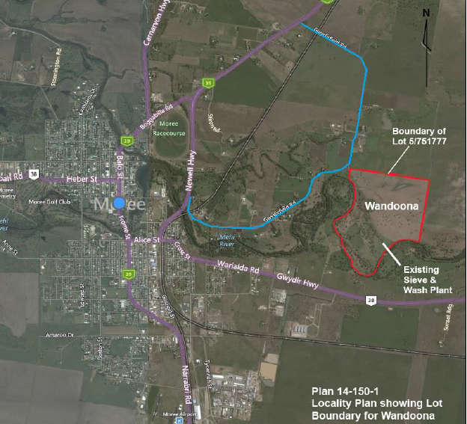

*Figure 2 Site Plans*

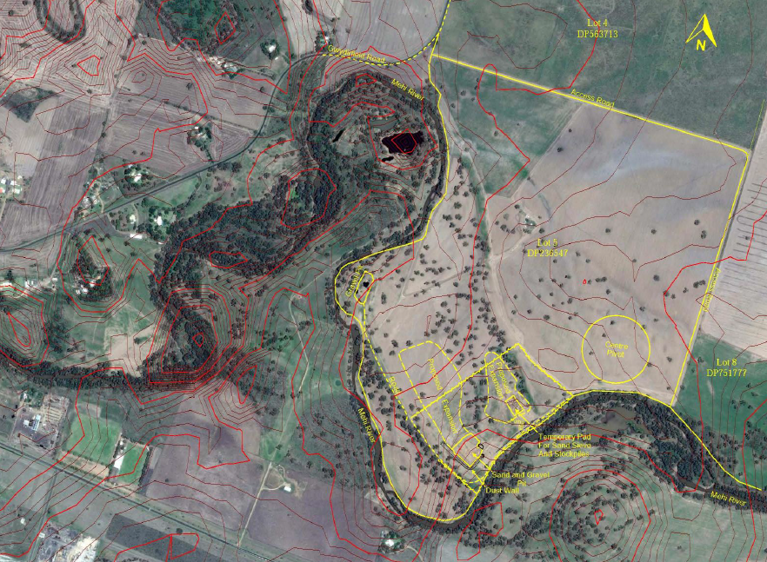

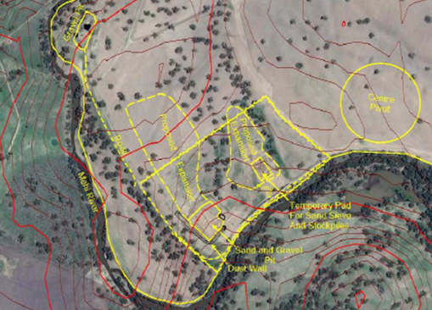

1. **Statutory Development Assessment Framework**

### Permissibility

**Regionally Significant development**

The site is zoned RU1 - Primary Productionunder Moree Plains Local Environmental Plan 2011 (**LEP**) as shown in the figure below. The development proposal is defined as an ‘extractive industry’ and is permissible under the LEP Land Use Table.

*Figure 3 Land Use Zoning map RU1 Primary Production*

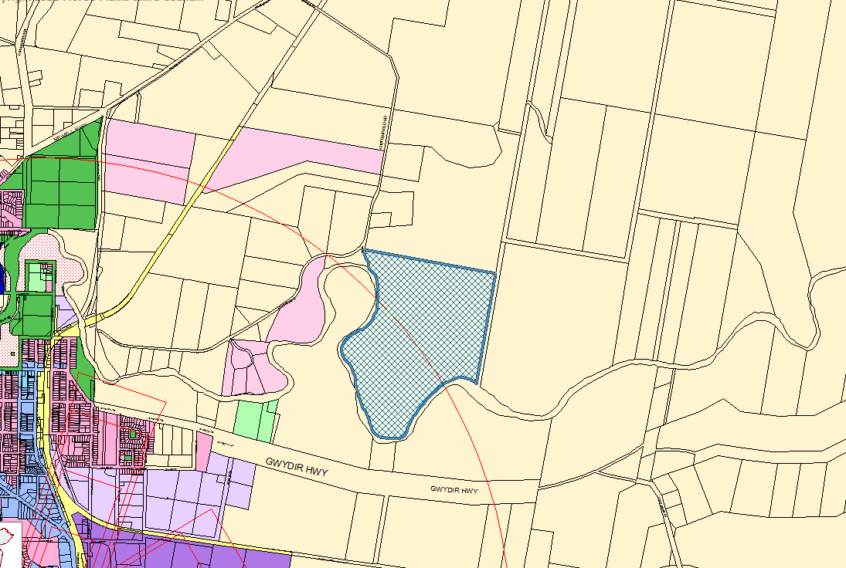

### Public Participation

The development application (**DA**) was publicly notified as required by the provisions of the Moree Plains Development Control Plan 2013 (**DCP**).

The DA was publicly notified and exhibited for a period of 28 days commencing 4 August 2016and closing 5 September 2016.The notification included letters to property owners/occupiers if, in the opinion of the Council’s Planning and Development Department, the enjoyment of land adjoining the development may be detrimentally affected by the proposed development. Those properties that were notified are indicated in the figure below.

*Figure 5 Notification plan – Development site shaded green*

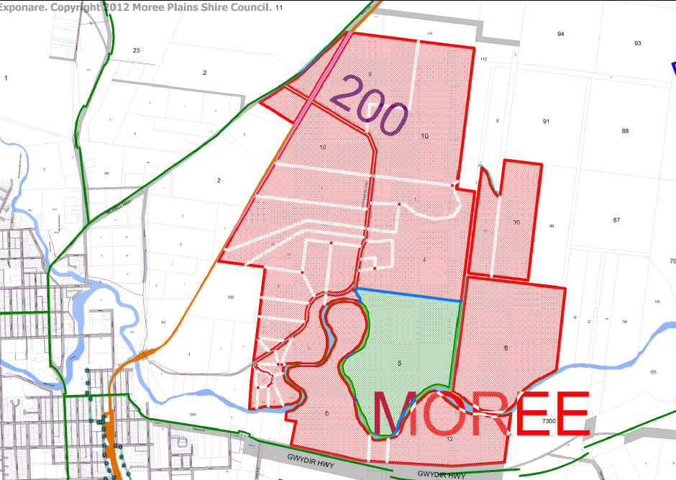

During the notification period four (4) submissions were received. The issues raised in the submissions are detailed as follows:

|  |  |
| --- | --- |
| **Issue** | **Comment** |
| Increased traffic from existing Wandoona quarry | Under current consent conditions for DA2014/58, the Quarry is limited to a maximum of 16 heavy vehicle movements per day. The Quarry has an annual limit of 29,000 cubic metres of sand. Subject to demand, the monthly extraction rate varies from approximately 1250 to 4000 tonnes. Assuming an average monthly extraction of 2,500 tonne per month, this equates to 100 single trailer loads or 25 truck trips per week. These loads are transported by 2 return truck movements per hour for 10 hours per day (. During increased operations for special projects, the truck frequency may be increased to 4 trucks per hour for a 10 hour day over a period of 2-3 days.  Annual extraction quantities are not proposed to change from the existing approved development. The proposal involves more regular use of road trains to increase load sizes and therefore decrease the total number of truck trips to and from the quarry.  Expected traffic under conditions of the proposal will constitute 2 road trains operating for 10 hours per day to transport quarry materials to the JCQ’s Drive Inn Road facilities. Under this scenario, 4 truck movements would be occurring per hour, for 2-3 days per month when averaged over a 12-month period. Approximately 1,000 tonnes of material could be transported per day.  This method of operation is more efficient when compared to using B-Doubles which require a total of 60 loads (totalling 60 road hours) per month over 8 days of quarry activity per month. Using two road trains requires 45 loads in total (totalling 45 road hours), with only 2-3 days of quarry activity per month (as two trucks would be working to transport the loads simultaneously). The proposal also involves supply of quarry materials to other projects at a similar traffic frequency.  The proposal therefore involves slightly increased intensity of traffic generation over shorter periods of time.  Council’s Engineering Department have advised that Gwydirfield Road has existing approval for Road Train Access. This means that trucks up to Road Train size are able to be legally used on this road. However the applicant will be responsible for upgrading the haul route along Gwydirfield Road to ensure a minimum sealed road width of 7.5 metres. Ongoing maintenance of the road will be levied under Council’s Draft Section 7.11 Development Contribution Plan for Traffic Generating Development. These requirements are included within the draft conditions.  The Wandoona property access point on Gwydirfield Road was upgraded under the previous Development Application. Council’s Engineering Department have reassessed this intersection and have confirmed that the current traffic management facilities meet the requirements for the proposed haul vehicles. The intersection now features truck turning signs, a give way sign and posted speed limit signs. As such Council’s Engineering Department do not object to the proposal. |

|  |  |
| --- | --- |
| Road safety on Gwydirfield Road would be compromised due to regular traffic from haul trucks. The road width is not adequate for vehicles passing trucks.  Gwydirfield Road has historically been a low-traffic road and remains a fairly narrow road. Does Gwydirfield Road have the capacity to be used by large haul trucks? | Council’s Engineering Department have advised that Gwydirfield Road is approved for Road Train Access, which would allow for access from haul vehicles for the development. This road usage approval has been based on a comprehensive road and safety assessment. Road trains have been permitted on Gwydirfield Road for some 30 years. However Council’s Engineering Department require that Gwydirfield Road be upgraded to provide a minimum 7.5 metre wide bitumen-seal along the haul route prior to commencement of the proposal.  Gwydirfield Road has a speed limit of 80km/h however, in the interests of safety, the applicant proposes a speed limit of 60km/h for heavy vehicles associated with the development.  The applicant will be required to implement a Traffic Management Plan for the development. |
| Who will pay for the additional road maintenance on Gwydirfield Road that would be required as a result of the development? | The proposal would be required to contribute to road maintenance via the Draft Moree Plains Shire Section 7.11 Development Contribution Plan for Traffic Generating Development 2020. This Plan is designed to cover increased maintenance costs resulting from increased road usage from developments. A condition requiring applicant contributions under the Plan is included within the draft consent. The contributions would be payable on all heavy vehicle traffic generated by the development. |
| Noise from truck and machinery movements, excavation activities, generators and pumps. | Project Specific Noise Levels (PSNL) for the site have been determined by the methodology outlined in the NSW Industrial Noise Policy (INP). The noise criteria was set at 35 dBALeq for the assessment of impacts associated with the proposed development. This criterion was conservatively applied, and represents the most stringent impact assessment criteria level that is generally permitted under the INP.  The model produced by the Environmental Noise Impact Assessment (ENIA) presents worse case noise impact for the proposed operations, comprising:  • Processing plant and stockpile operations and associated water pump operations  • Sand and gravel pit operations (belowground extraction of materials)  • Haul trucks transporting products from extraction pits to processing plant area; and  • Road trains hauling processed sand and gravel products  Operational noise monitoring was undertaken by SMK Consultants and determined that the LAeq,15min impacts associated with the existing development are slightly lower than those predicted in the ENIA for the proposed development operations. It is noted that operational activities associated with the proposed development will be very  similar to those of the existing development.  The Acoustic consultant has recommended the following mitigation strategies to reduce the potential impact of ongoing site operation. The strategies to be implemented include:  • Agison Water Pump – replace southern façade of wire mesh enclosure within solid barrier.  • Sand and Gravel Pit – installation of a 3m high, earthen mound acoustic barrier on the eastern and southern sides of the pit.  • Ridge Gravel Pit – installation of a 1m high earthen mound acoustic barrier on the south-eastern side of the pit.  • Processed sand and loading operations to be arranged so that trucks serve as a temporary barrier between loader movements and Receiver 1 (being the closest dwelling to the south of the proposal).  Based on these modelled conditions, noise generated from the quarry can be expected to produce only a minor 1dB(A) intrusive noise impact upon Receiver 1, under worst case conditions. Under neutral conditions, the noise impact generated by quarry operations falls beneath the conservative adopted PSNL for all sensitive noise receivers.  The proposed expansion of the quarry is not expected to significantly alter the frequency of noise emissions from the site. The proposal would enable the continuation of the quarry’s life. Whilst noise from vehicles and machines will impact on nearby receptors the level of operation is not constant and would generally be limited to daylight hours. No blasting operations are proposed by this development.  Vibration levels are expected to be below the threshold of human detection, before reaching the property boundary.  It is recommended that noise management be addressed in detail within an Operations Environmental Management Plan, as per the draft conditions. The OEMP shall include effective noise controls for the Sand Sieve and stockpile/loading operations. |

|  |  |
| --- | --- |
| Dust from truck movements and excavation activities | The intersection of Gwydirfield Road and the “Wandoona” driveway was upgraded in 2015 as part of an earlier quarry Development Application at the site (DA2014-58).  The proposed condition on access requires all internal roads to be maintained to an all-weather standard with hard gravel surface for the life of the development. Watering trucks would be used as necessary when haul trucks are active.  Dust management will be an important part of the Operations Environmental Management Plan.  In order to protect the public interest during the operation of the development, a complaints management mechanism is recommended as a condition of consent. |
| Water supply from bore and capacity to provide for the proposed quarry in addition to existing neighbouring bores for stock and domestic purposes. | The bore located on site (Licence 90BL153464) is solely utilised for stock and domestic purposes and is not involved with the existing Quarry operations or proposed expansion. The proposed development does not involve any additional extraction or changes to the aquifer and is therefore consistent with the relevant rules of the Water Sharing Plan for the Gwydir Regulated River Water Source.  The allowable extraction from the river under WAL13284 is 18 units (equivalent to 18 ML) per year. The proposal includes the use of a portable sieving plant for washing and processing the sand. The water requirements of the plant average 1 ML/ month, for a total of 12 – 17 ML/ year. The allowable extraction limit exceeds the average water requirements and is considered a reliable water source for the proposed Quarry expansion. |
| Hours of operation – concern regarding the proposed extended hours of 6am until 10pm for maintenance of plant and equipment | Truck haulage hours will be between the hours of 7:00am and 5:00pm on weekdays and 7:00am to 3:00pm on Saturdays.  Light vehicle traffic associated with the development would not be restricted.  Plant and equipment maintenance activities may occur within the site from 6am until 10pm Monday to Friday. There would also be provisions for maintenance and operation of equipment within the property on any day. The extended hours would not include heavy vehicle movements to or from the site and would be limited to activities with low impact and those within the quarry pit area. Such activities would be undertaken on an infrequent basis and would be subject to the draft conditions of consent relating to environmental impact.  In between projects, the site would remain closed and no activity would occur other than oc-casional site inspections for assessment of gravel reserves or minor maintenance such as fence repairs. |
| Flood impacts from stockpiles or overburden on neighbouring properties | Within Wandoona exists a ridge line which runs through the middle of the property before falling off to the southern side leading into the Mehi River.  The stockpiles of topsoil/overburden from the existing southern pit has been stacked in an east-west direction to minimise the impact of the materials during a flood event. The stockpiles are located along a ridge and are considered to be in a low-hazard flood area.  The proposal would result in the net removal of material so there would be no displacement of flood waters. No other significant banks or raised areas are required for the development that may interfere with or impact on flood flows. |
| Koala habitat – the EIS states that “no resident koala population is present nor were any scats located around the base of these trees.” However neighbours have observed koalas in the vicinity of the site on various occasions in the past. | The applicant has provided a State Environmental Planning Policy (Koala Habitat Protection) 2019assessment within the Environmental Impact Statement. The Policy aims to encourage the conservation and management of areas of natural vegetation that provide habitat for koalas.  The NSW Department of Planning, Industry and the Environment’s online mapping tool was  used to determine the assessment of koala habitat value within the proposal footprint  and its vicinity. The proposed development site has been mostly cleared and developed for  farming and cultivation. A single mature tree within the development footprint is included in  the Site Investigation Area for Koala Plans of Management layer.  Anecdotal evidence from neighbouring landholders suggests that Koalas have been  witnessed within the area. The site is bordered by River Red Gums which are a listed feed  tree species for Koala habitat. Assessment of the site indicated that there is a small potential  for Koalas to pass through the area as part of the Mehi River corridor.  A search of the Atlas of NSW Wildlife revealed 26 records of Koala within 10km of the quarry  from 2004 to 2018. Sighting notes pertaining to these records describes a large proportion of  these individuals as sick/diseased, stranded, attacked, or victims of collisions, suggesting they  are outliers rather than part of a healthy population.  No scats were recorded around the base of these trees during site inspection. One tree would be cleared as part of the proposed works. Trees bordering the development will also be retained within the development with sufficient distance to continue their growth without disturbance to the tree roots. As there are no Koalas present  on the property and no historic records of the site being utilised by Koalas, the area cannot be classified as “Core Koala Habitat”. On this basis, the proposed development and continuing use of the land for farming purposes is not considered a threat  to regional Koala populations or migration corridors. |
| The proposed sieving plant would be closer to the neighbouring dwelling to the south | The proposed sieving plant would be located more centrally within the quarry site. This has the benefit of being closer to overburden stockpiles which would reduce noise impacts on the nearest property to the south. The existing sieving plant location did not have such protection. |

### Referrals

Internal - Council Engineering Department

External - NSW Rural Fire Service

* Department of Primary Industries – Water
* Roads and Maritime Services
* Department of Industry
* Office of Environment and Heritage
* Department of Primary Industries - Agriculture

### Section 4.15 assessment

In determining a DA, a consent authority is to take into consideration matters referred to in section 4.15(1) of the EPA Act (previous s 79C) as are of relevance to the development the subject of the application. The relevant matters for this application are detailed below:

1. **4.15 Evaluation– any environmental planning instrument; any proposed instrument that is or has been the subject of public consultation under this Act and that has been notified to the consent authority, any development control plan, any planning agreement entered into under Section 7.4 or any draft planning agreement that a developer has offered to enter into under Section 7.4, and the Regulations;**

***Environmental Planning & Assessment Act, 1979 and Environmental Planning & Assessment Regulation, 2000***

**Designated development**

Schedule 3 of the EP&A Regulation provides thresholds for “extractive industries” which may be considered designated development under the EP&A Act and associated regulations.

*Environmental Planning and Assessment Regulation 2000*

*Schedule 3 Designated development*

*19 Extractive industries*

*(1) Extractive industries (being industries that obtain extractive materials by methods including excavating, dredging, tunnelling or quarrying or that store, stockpile or process extractive materials by methods including washing, crushing, sawing or separating):*

*(a) that obtain or process for sale, or reuse, more than 30,000 cubic metres of extractive material per year, or*

***(b) that disturb or will disturb a total surface area of more than 2 hectares of land by:***

***(i) clearing or excavating, or***

***(ii) constructing dams, ponds, drains, roads or conveyors, or***

***(iii) storing or depositing overburden, extractive material or tailings****, or*

***(c) that are located:***

***(i) in or within 40 metres of a natural waterbody, wetland or an environmentally sensitive area****, or*

*(ii) within 200 metres of a coastline, or*

*(iii) in an area of contaminated soil or acid sulphate soil, or*

*(iv) on land that slopes at more than 18 degrees to the horizontal, or*

*(v) if involving blasting, within 1,000 metres of a residential zone or within 500 metres of a dwelling not associated with the development, or*

*(vi) within 500 metres of the site of another extractive industry that has operated during the last 5 years.*

*(2) This clause does not apply to:*

*(a) extractive industries on land to which the following environmental planning instruments apply:*

*(i) Sydney Regional Environmental Plan No 11—Penrith Lakes Scheme,*

*(ii) Western Division Regional Environmental Plan No 1—Extractive Industries, or*

*(b) maintenance dredging involving the removal of less than 1,000 cubic metres of alluvial material from oyster leases, sediment ponds or dams, artificial wetland or deltas formed at stormwater outlets, drains or the junction of creeks with rivers, provided that:*

*(i) the extracted material does not include contaminated soil or acid sulphate soil, and*

*(ii) any dredging operations do not remove any seagrass or native vegetation, and*

*(iii) there has been no other dredging within 500 metres during the past 5 years, or*

*(c) extractive industries undertaken in accordance with a plan of management (such as river, estuary, land or water management plans), provided that:*

*(i) the plan is prepared in accordance with guidelines approved by the Planning Secretary and includes consideration of cumulative impacts, bank and channel stability, flooding, ecology and hydrology of the area to which the plan applies, approved by a public authority and adopted by the consent authority and reviewed every 5 years, and*

*(ii) less than 1,000 cubic metres of extractive material is removed from any potential extraction site that is specifically described in the plan, or*

*(d) the excavation of contaminated soil for treatment at another site, or*

*(e) artificial waterbodies, contaminated soil treatment works, turf farms, or waste management facilities or works, specifically referred to elsewhere in this Schedule, or*

*(f) development for which State Environmental Planning Policy No 52—Farm Dams and Other Works in Land and Water Management Plan Areas requires consent, or*

*(g) maintenance dredging of alluvial material from oyster leases and adjacent areas in Wallis Lake, but only if the dredging is undertaken in accordance with the document entitled Protocol for Wallis Lake Oyster Lease Maintenance Dredging approved by the Planning Secretary and published in the Gazette, as amended by the Planning Secretary from time to time by publication of an amended Protocol in the Gazette.*

The proposed development triggers the provisions 1(b)(i), 1(b)(ii), 1(b)(iii), and 1(c)(i).

**Integrated development**

The proposed quarry is not considered to be integrated development under Division 4.8 of the EP&A Act as it does not require any additional approval / permit / licence / authorisation under the:

* Fisheries Management Act 1994;
* Heritage Act 1977;
* Mine Subsidence Act Compensation Act 1961;
* Mining Act 1992;
* National Parks and Wildlife Act 1974
* Petroleum (Onshore) Act 1991;
* Protection of the Environment Operations Act 1997;
* Roads Act 1993;
* Rural Fires Act 1997; or
* Water Management Act 2000.

***Environment Protection and Biodiversity Conservation Act 1999***

The Environment Protection and Biodiversity Conservation Act, 1999 (EPBC Act) requires the approval of the Commonwealth Minister for the Environment for actions on Commonwealth land or those that may have a significant impact on matters of national environmental significance, which are:

* world heritage areas,
* national heritage places,
* wetlands of international importance (RAMSAR Sites),
* threatened species and ecological communities listed in the EPBC Act,
* migratory species listed in the EPBC Act,
* nuclear actions, and
* actions affecting the Commonwealth marine environment.

The listed matters of national significance and threatened species are considered in the flora and fauna assessment appended to the EIS.

Given that the site has a history of significant disturbance and that the proposed changes to existing operations are considered to be minor, the proponent’s contention that the potential impact on Commonwealth matters is negligible is accepted.

***National Parks and Wildlife Act 1974***

The National Parks and Wildlife Act 1974 provides for the protection of native flora and fauna and the protection, preservation and management of Aboriginal relics throughout NSW regardless of land tenure. A flora and fauna assessment and Aboriginal cultural heritage assessment has been provided in the EIS. The assessment concluded that the proposed development does not pose a risk to threatened species, populations or communities.

***Threatened Species Conservation Act 1995***

The Threatened Species Conservation Act 1995 (TSC Act) provides protection for threatened flora and fauna native to NSW and integrates the conservation of threatened species into the development approval process under the Environmental Planning and Assessment Act 1979 through the use of a seven-part test. A seven-part test has been undertaken for the proposed development. The lodgement of this Development Application pre-dates the Biodiversity Conservation Act 2016 (BC Act) so the TSC Act applies. However a Test of Significance has been conducted under the BC Act.

***Protection of the Environment Operations Act 1997***

The Protection of the Environment Operations Act 1997 establishes procedures for the issue of Environmental Protection Licences for Scheduled works and premises. The proposal would not require an Environmental Protection licence in relation to extracting gravel as annual extraction will not exceed a 30,000 tonne threshold in any one-year period.

***Water Management Act 2000***

The Water Management Act 2000 established a comprehensive statutory framework for the management of water in NSW. The object of the Water Management Act 2000 is the sustainable and integrated management of the State's water for the benefit of both present and future generations. In particular, the framework covers volumetric licensing in areas covered by water sharing plans, including the subject area, and controls development activities within 40m of waterfront land.

A water management work approval is required to carry out work within the 40 m buffer zone along the river. The “work” would be defined as activity that occurs in or in the vicinity of a river, estuary or lake, or within a floodplain, and is of such a size or configuration that (regardless of the purpose for which it is constructed or used), it is likely to have an effect on the flow of water to or from a river, estuary or lake, or the distribution or flow of floodwater in times of flood.

The existing internal haul road is located within 40 m of the river in parts. DPI Water have met onsite with the proponent. If works are required on this road, the Proponent would be obliged to submit an application for consideration to DPI Water. The proposed development does not include any initial requirement to obtain this approval as this is an existing road which had been developed prior to the current sand extraction operating being approved. The use of this road is not subject to a separate application process.

Other matters relating to the WMA 2000 include the use of water from the Mehi River. This has been addressed by obtaining a Works Licence and a Water Access Licence for the existing pump and allocation for the current operation.

***Heritage Act 1977***

The Heritage Act 1977 provides for the protection of the State’s natural, built, marine and moveable heritage. The Act establishes the Heritage Council of NSW which maintains the State Heritage Register and Inventory. No heritage items recorded on the Register or the Inventory are located on the subject land.

***Contaminated Land Management Act 1997***

The Contaminated Land Management Act 1997 establishes a process for investigating and (where appropriate) remediating land areas where contamination presents a significant risk of harm to human health or some other aspect of the environment. The Act provides that the EPA may declare land to be contaminated and to declare investigation areas. The EPA has not declared the subject land to be contaminated land nor part of an investigation area.

***State Environmental Planning Policies***

**State Environmental Planning Policy (Mining, Petroleum Production and Extractive Industries) 2007**

This SEPP has the following aims:

*a) To provide for the proper management and development of mineral, petroleum and extractive material resources for the purpose of promoting the social and economic welfare of the State, and*

*b) To facilitate the orderly and economic use and development of land containing mineral, petroleum and extractive material resources, and*

*c) To establish appropriate planning controls to encourage ecologically sustainable development through the environmental assessment, and sustainable management, of development of mineral, petroleum and extractive material resources.*

Clause 12 of the SEPP provides a number of matters that a consent authority must consider before determining a development application. These matters are similar to, but are in different terms to; the relevant matters contained in the LEP and are considered in the body of this report.

Clause 13 requires that Council must consider the compatibility of development proposals on land in the vicinity of existing mines etc. or of land containing mineral or extractive resources. This provision is to ensure that these resources are not sterilised by incompatible development on surrounding land and is a matter for Council to consider. The proposed development involves a long term plan to maintain access to a historically used gravel resource.

Clause 16 (3) provides that the consent authority must not determine the development application until it has taken into consideration any submission received from the roads authorities and the Roads and Maritime Service (RMS). RMS made submission on the proposal which has been considered in this assessment.

Clause 17 requires that the consent authority must consider whether or not the consent should be issued subject to conditions requiring rehabilitation of the land affected by the development. This is a matter for Council and rehabilitation is considered below. The project proposal includes a rehabilitation component.

**State Environmental Planning Policy (Koala Habitat Protection) 2019**

The applicant has provided a State Environmental Planning Policy ( No. 44 – Koala Habitat Protection) 2019 (SEPP 44) assessment within the Environmental Impact Statement. The Policy aims to encourage the conservation and management of areas of natural vegetation that provide habitat for koalas.

The NSW Department of Planning, Industry and the Environment’s online mapping tool was

used to determine the assessment of koala habitat value within the proposal footprint

and its vicinity. The proposed development site has been mostly cleared and developed for

farming and cultivation. A single mature tree within the development footprint is included in

the Site Investigation Area for Koala Plans of Management layer.

It is suggested that the SEPP 44 assessment be updated to provide a current site assessment. The updated report should include documented observations from local residents. Should the report find that the site has been inhabited or that it should be classified as “Core Koala Habitat” the proposal shall be amended accordingly. Under the draft conditions the updated SEPP 44 report would need to be submitted to and endorsed by Council prior to the commencement of site operations for this DA.

Anecdotal evidence from neighbouring landholders suggests that Koalas have been

witnessed within the area. The site is bordered by River Red Gums which are a listed feed

tree species for Koala habitat. Assessment of the site indicated that there is a small potential

for Koalas to pass through the area as part of the Mehi River corridor.

A search of the Atlas of NSW Wildlife revealed 26 records of Koala within 10km of the quarry

from 2004 to 2018. Sighting notes pertaining to these records describes a large proportion of

these individuals as sick/diseased, stranded, attacked, or victims of collisions, suggesting they

are outliers rather than part of a healthy population.

No scats were recorded around the base of these trees during site inspection. One tree would be cleared as part of the proposed works. Trees bordering the development will also be retained within the development with sufficient distance to continue their growth without disturbance to the tree roots. As there are no Koalas present

on the property and no historic records of the site being utilised by Koalas, the area cannot be classified as “Core Koala Habitat”. On this basis, the proposed development and continuing use of the land for farming purposes is not considered a threat

to regional Koala populations or migration corridors.

**State Environmental Planning Policy No 55 – Remediation of Land**

The objective of this policy is to provide a State-wide planning approach for the remediation of contaminated land. Where it is proposed to rezone the land or to carry out a development that would change the use of the land a consent authority must consider whether the land is contaminated and if it is, whether the land is suitable for the proposed development in its present state or whether remediation is required. Even where no change of use is proposed a consent authority must consider whether the land is suitable for the proposed development if the land has been used for a purpose listed in Table 1 to the contaminated land planning guidelines. The subject land has been utilised for cultivation and grazing prior to the quarry opening and adjoining land is used for either residential or similar agricultural practices.

The Preliminary Assessment required by SEPP 55 is attached at Appendix 6 to the EIS.

The assessment considered the lands’ past and its present uses and concluded that it is unlikely for there to be contamination such as to render the land unsuitable for the present and proposed uses.

**State Environmental Planning Policy (Rural Lands) 2008**

The aims of this Policy are as follows:

* + - 1. To facilitate the orderly and economic use and development of rural lands for rural and related purposes,

**Comment:** The proposal is for the use of rural land for an extractive industry and is considered to comply with this aim. There is a widespread scarcity of quarry aggregate which the proposal would help to address.

* + - 1. To identify the Rural Planning Principles and the Rural Subdivision Principles so as to assist in the proper management, development and protection of rural lands for the purpose of promoting the social, economic and environmental welfare of the State,

**Comment:** The proposal is considered to be in accordance with the Rural Planning Principles (reproduced below). The Rural Subdivision Principles do not apply as no subdivision of land is proposed.

* + - 1. To implement measures designed to reduce land use conflicts,

**Comment:** The proposal is considered to be generally compatible with adjacent land uses which are predominately agricultural and rural/residential in nature. The proposal includes measures to mitigate impacts from noise, dust and traffic movements.

* + - 1. To identify State significant agricultural land for the purpose of ensuring the ongoing viability of agriculture on that land, having regard to social, economic and environmental considerations,

**Comment:** The subject land is mapped as being Biophysical Strategic Agricultural Land in the New England North West Regional Plan 2036. The proposal would be compatible with the agricultural use of the balance of the property. The significant demand for sand and gravel aggregate in the broader area is noted.

* + - 1. To amend provisions of other environmental planning instruments relating to concessional lots in rural subdivisions.

**Comment:** Not relevant

**Rural Planning Principles**

The Rural Planning Principles are as follows:

* + - 1. The promotion and protection of opportunities for current and potential productive and sustainable economic activities in rural areas,

Comment: The proposed quarry would provide sand and gravel aggregate which are scarce resources in this region. The applicant is an established local business.

* + - 1. Recognition of the importance of rural lands and agriculture and the changing nature of agriculture and of trends, demands and issues in agriculture in the area, region or State,

Comment: The proposal is considered to complement the predominate agricultural land uses, with land not utilised for the quarry continuing to be used for agriculture.

* + - 1. Recognition of the significance of rural land uses to the State and rural communities, including the social and economic benefits of rural land use and development,

Comment: The proposal is considered to comprise a rural land use. It would provide quarry materials which have an economic benefit for the local area.

* + - 1. In planning for rural lands, to balance the social, economic and environmental interests of the community,

Comment: The proposal is considered to be capable of managing social, economic and environmental interests. A range of stakeholders have been consulted on the proposal and the views expressed have contributed to the nature of the development.

* + - 1. The identification and protection of natural resources, having regard to maintaining biodiversity, the protection of native vegetation, the importance of water resources and avoiding constrained land,

Comment: The proposal is considered to comply with this principle as it will extract sand and gravel from land which has historically been cropped for agricultural purposes. The applicant does not propose to remove any trees or native vegetation.

* + - 1. The provision of opportunities for rural lifestyle, settlement and housing that contribute to the social and economic welfare of rural communities,

Comment: Not relevant.

* + - 1. The consideration of impacts on services and infrastructure and appropriate location when providing for rural housing,

Comment: Not relevant

* + - 1. Ensuring consistency with any applicable regional strategy of the Department of Planning or any applicable local strategy endorsed by the Director-General.

Comment: The proposal is considered to be consistent with the New England North West Regional Plan 2036, which is addressed later in this report.

The proposed development is considered to be compatible with adjacent land uses. It is expected that the proposal has manageable impacts and would complement existing agricultural operations.

**State Environmental Planning Policy (State and Regional Development) 2011**

The State and Regional Development SEPP identifies significant development and infrastructure and confer functions on regional panels to determine development applications.

The application is classified as ‘Regional Development’ and has been assessed by Moree Plains Shire Council for determination by the Northern Regional Panel in accordance with this SEPP. The development is for the purposes of extractive industries, which meet the requirements for designated development under clause 19 of Schedule 3 to the Environmental Planning and Assessment Regulation 2000. This is outlined in Schedule 7 of the State Environmental Planning Policy (State and Regional Development) 2011.

***New England North-West Regional Plan 2036***

The New England North West Regional Plan 2036 (the Plan) recognises that this region provides mineral resources and raw materials for major infrastructure projects,

new housing, and industrial and agricultural

businesses.

The site is mapped as comprising Biophysical Strategic Agricultural Land according to Figure 4 of the Plan. The proposal is considered to be compatible with the agricultural use of the balance of the property.

The Plan outlines twenty-four Strategic Directions for the North West Slopes and Plains region in NSW. Strategic Direction Number 4 is to ‘Sustainably manage mineral resources’. The Plan encourages the following actions to be taken to achieve this goal:

4.1 Consult with the NSW Division of Resources and Geoscience when assessing

applications for land use changes (strategic land use planning, rezoning and planning

proposals) and new developments or expansions.

4.2 Protect areas of mineral and energy resource potential through local strategies and local environmental plans.

4.3 Protect infrastructure that facilitates mining from development that could

affect current or future extraction.

The proposed development is not contrary to actions associated with Strategic Direction Number 4 of the Plan.

***Moree Plains Local Environmental Plan 2011 (LEP)***

**Land Use Table**

The land is zoned RU1 - Primary Production under the LEP. The zone objectives as provided in the Land Use Table are:

* *To encourage sustainable primary industry production by maintaining and enhancing the natural resource base.*
* *To encourage diversity in primary industry enterprises and systems appropriate for the area.*
* *To minimise the fragmentation and alienation of resource lands.*
* *To minimise conflict between land uses within this zone and land uses within adjoining zones.*
* *To permit development for certain purposes if it can be demonstrated that suitable land or premises are not available elsewhere.*

Under clause 2.3(2) of the LEP, the consent authority must have regard to the objectives for development in a zone when determining a development application in respect of land within the zone. It is considered that the proposed quarry is consistent with the third objective as it would utilise resource lands at an existing quarry site.

The proposed quarry is defined as an “extractive industry” under the Moree Plains Local Environmental Plan 2011 (LEP).

“Extractive industry” is defined as follows in the LEP:

*“Extractive industry means the winning or removal of extractive materials (otherwise than from a mine) by methods such as excavating, dredging, tunnelling or quarrying, including the storing, stockpiling or processing of extractive materials by methods such as recycling, washing, crushing, sawing or separating, but does not include turf farming.”.*

The subject site is located within the RU1 – Primary Production Zone (RU1 Zone). Under the RU1 Zone, within the LEP, “extractive industries” are permitted with consent.

**Clause 5.10 – Heritage conservation**

Heritage was considered during the assessment. In brief, it is concluded that the site does not contain any European heritage items, conservation areas or indigenous places or objects.

The site is not identified as or located near a known Aboriginal Place of Heritage Significance on the Aboriginal Cultural Significance map or in the Moree Plains Aboriginal Heritage Study and therefore no Aboriginal Heritage Impact Assessment is required.

**Clause 7.6 Flood Planning**

The subject land is identified as flood-prone, however the proposal is for non-habitable development. The proposed development involves extractive land uses and the operation of a sieving and screening plant. The stockpiles of topsoil/overburden from the existing southern pit has been stacked in an east-west direction to reduce noise impacts for the property south of the development and to minimise the impact of the materials during a flood event. The stockpiles are located along a ridge and are considered to be in a low-hazard flood area.

The proposal would result in the net removal of material and, coupled with the strategic storage location of overburden (as noise barriers and on high ridge areas), would cause minimal displacement of flood waters.

Whilst the proposed development is identified as a flood control lot it meets the objectives of clause 7.6 of the LEP.

**Clause 7.7 Places of Aboriginal cultural significance**

The development is not located on land identified as “place of Aboriginal cultural significance”.

***Moree Plains Development Control Plan 2013 (DCP)***

**Chapter 2 – Parking**

The ‘Performance Outcomes’ of the DCP require new car parks to be sufficient in number and design to provide appropriately for the needs of new developments. The nature of the proposed quarry operations is such that designated parking is unnecessary, and as such is not required.

**Chapter 4 – Moree & Environs Floodplain Development and Management**

The subject land is identified as flood-prone however the proposal is for non-habitable development. The proposed development involves extractive land uses and the operation of a sieving and screening plant. The development is able to proceed in a way that minimises impacts on flood behaviour and the development itself. The stockpiles of topsoil/overburden from the existing southern pit has been stacked in an east-west direction to reduce noise impacts for the property south of the development and to minimise the impact of the materials during a flood event. No other significant banks or raised areas are required for the development that may interfere with or impact on flood flows.

The proposed development meets the ‘Performance Outcomes’ of the DCP. This assessment indicates that the proposal would not materially increase the risk to life from flooding and is considered to have negligible impact on the flood afflux levels.

**Chapter 9 – Rural Development**

This chapter addresses various aspects of rural development including biodiversity, bushfire management, recreational vehicles, feedlots, access to rural properties and dwelling development.

Quarries are not specifically discussed in this chapter although the development addresses relevant issues such as land use compatibility and rural sustainability.

**Chapter 10 – Notification Policy**

The DA was publicly notified and exhibited for a period of 28 days commencing 4 August 2016 and closing 5 September 2016. The notification included letters to property owners/occupiers if, in the opinion of the Planning and Building Section, the enjoyment of land adjoining the development may be detrimentally affected by the proposed development.

During the notification period four (4) submissions were received. The issues raised in the submissions are outlined earlier in this report.

The proposed development complies with all aspects of Moree Plains Development Control Plan 2013.

1. **Section 4.15(1)(b) – the likely impacts of the development, including environmental impacts on both the natural and built environments, and social and economic impacts on the locality:**

It is considered that the likely impacts of the development including design, height, car parking, traffic, flood impacts and drainage have been satisfactorily addressed.

The proposed development has been designed in compliance with the acceptable solutions of the DCP and it is believed that the proposed development will not have any unfavourable social or environmental impacts.

1. **Section 4.15 (1)(c) - the suitability of the site for development;**

In considering the suitability of the site for the development Council should have regard to the zoning of the site and its objectives under the current environmental planning instrument (LEP) and the permissibility of the development under the LEP. The proposed quarry is defined as an “extractive industry” under the Moree Plains Local Environmental Plan 2011 (LEP). Under the RU1 Zone, within the LEP, “extractive industries” are permitted with consent.

In terms of assessing the various aspects of the proposal, direction has been taken from the planning principles adopted by the Land and Environment Court of NSW.

***Davies v Penrith City Council [2013] NSWLEC 1141***

In this case, Moore, SC revised the *criteria for assessing impact on neighbouring properties within this Planning Principle.*

*The following questions are relevant to the assessment of impacts on neighbouring properties:*

* *How does the impact change the amenity of the affected property? How much sunlight, view or privacy is lost as well as how much is retained?*

Comment: Noise impacts on the closest private dwelling to the south of the development is a key focus of this assessment. Based on the modelled worst-case conditions, noise generated from the quarry can be expected to produce a minor 1dB(A) intrusive noise impact upon the dwelling to the south. Under neutral conditions, the noise impact generated by quarry operations falls beneath the conservative adopted Project Specific Noise Levels (PSNL) for all sensitive noise receivers.

* *How reasonable is the proposal causing the impact?*

Comment: The proposal is for the expansion of an existing approved sand and gravel quarry. Project Specific Noise Levels (PSNL) for the site have been determined under the NSW Industrial Noise Policy (INP). The noise criterion was conservatively applied, and represents the most stringent impact assessment criteria level that is generally permitted under the INP.

The proposed expansion of the quarry is not expected to significantly alter the frequency of noise emissions from the site. The proposal would enable the continuation of the quarry’s life. Whilst noise from vehicles and machines will impact on nearby receptors the level of operation is not constant and would be limited to daylight hours. Vibration levels are expected to be below the threshold of human detection, before reaching the property boundary.

The acoustic consultant has recommended several mitigation strategies to reduce the potential impact of ongoing site operation.

The model presents worst-case noise impact for the proposed operations. The noise impacts from the proposal would be similar to the existing development and is considered to be generally acceptable. Site operations would need to be suspended or modified should noise impacts exceed the Project Specific Noise Levels.

* *How vulnerable to the impact is the property receiving the impact? Would it require the loss of reasonable development potential to avoid the impact?*

Comment: The proposal would cause minor and infrequent noise impacts on the dwelling to the south. It is recommended that noise management be addressed in detail within the Operations Environmental Management Plan. The OEMP shall include effective noise controls for the sand sieve and stockpile/loading operations. In addition, certain noise generating operations may need to be ceased during unfavourable weather conditions eg, winds from north to south.

* *Does the impact arise out of poor design? Could the same amount of floor space and amenity be achieved for the proponent while reducing the impact on neighbours?*

Comment: The project design is considered to be acceptable given the location of the sand and gravel reserves.

* *Does the proposal comply with the planning controls? If not, how much of the impact is due to the non-complying elements of the proposal?*

Comment: The proposal in accordance with the relevant planning controls.

The proposal is considered to meet the relevant objectives of the RU1 - Primary Production zone, complies with the flood planning clause of the LEP and performance outcomes of the DCP. On this basis the development is considered generally appropriate for the site.

The subject site is considered suitable for the proposed development for the following reasons:

•  The subject site is within a rural/agricultural area and contains an existing approved sand and gravel quarry

* + - Annual quarry extraction tonnages and methods of extraction would not be altered from the existing approved quarry.

•  The proposed development is able to mitigate any potential impacts and is compatible with existing land uses in the locality

* The proposed development is permissible within the RU1 Primary Production zone under the Moree Plains Local Environmental Plan 2011.
* Access to the subject site is available from Gwydirfield Road and the Newell Highway

1. **Section 4.15 (1) (d) – any submissions made in accordance with the Act or the Regulations;**

As discussed earlier.

1. **Section 4.15 (1) (e) – the public interest.**

The proposal has been designed in line with the adopted standards of the DCP and as such, development consent of this proposal will not undermine the public interest.

1. **Recommendation**

It is recommended that DA2016/45 be approved subject to the draft conditions contained in Appendix 1.

**APPENDIX 1 – DRAFT CONDITIONS OF CONSENT**